September 2, 2024

Tsebo Letele fAVOUR AJAYI

ST10364068 ST10022295

GROUP 3 GROUP 3

WEDE6021

POE PART 1: SECTION 2

**INTRODUCTION**

The purpose of this web application, "Pastimes," is to provide a platform for the purchase and sale of branded, gently worn clothing. The program is designed to be reliable, secure, and easy to use. It has features that make selling used clothes simple and comfortable for users.

**OVERVIEW**

"Pastimes," a website application, functions as an online marketplace where users can purchase and sell used branded clothing. In addition to serving as a middleman between buyers and sellers, administrators will oversee the platform's efficient operation. To ensure the quality and legitimacy of the goods being sold, the website has user and clothing verification procedures. The website has several important features, such as a powerful search engine, easy-to-use navigation, quick view choices for clothes, and a community-focused blog area.

The web application will have the following features:

* User registration and login: Users can create an account to access personalized features and manage their buying and selling activities.
* Product listing: Users can browse a curated selection of clothing items with detailed descriptions, including brand, condition, price, and authenticity information if needed.
* Advanced search and filter: Users can search for items by brand, category, size, or other criteria and use filters to narrow down their options.
* Product listing: Users can browse a curated selection of clothing items with detailed descriptions, including brand, condition, price, and authenticity information if needed.
* Advanced search and filter: Users can search for items by brand, category, size, or other criteria and use filters to narrow down their options.
* Purchase and payment: A secure and straightforward checkout process that supports multiple payment methods.
* Virtual closet: Users can manage their wardrobe and receive personalized recommendations based on their current items.
* Seller functionality: Sellers can list their clothing items for sale, with all products undergoing a verification process to ensure authenticity if needed.
* Sustainability impact tracking: Users can view the environmental impact of their purchases, encouraging more eco-friendly decisions.
* Communication and support: The platform offers customer support and communication channels to ensure a smooth transaction process for both buyers and sellers.
* Personalized recommendations: This is driven based on past shopping, users will see recommendation on what the users has bought before and similar items they will like.

**FUNCTIONS**

* User registration and login: Users register by providing essential information, such as name, email address, and password. This allows them to create an account where they can manage their purchases, sales, and preferences.
* Product listing: Users can explore a wide range of fashion items, organized by brand, category, and other relevant filters. Each listing includes detailed information about the item's condition, price, and authenticity.
* Advanced search and filter: Users can search for specific items by entering keywords or using advanced filters to refine their search results based on brand, size, condition, and price range.
* Purchase and payment: Users can add items to their shopping cart and proceed to checkout, where they can choose from various secure payment options. The process is designed to be fast and user-friendly.
* Virtual closet: Users can upload their existing wardrobe to the virtual closet feature, which helps them organize their fashion items and receive suggestions for complementary pieces available on the platform.
* Seller functionality: Sellers can list their pre-owned clothing items by providing details such as brand, condition, and price. The platform's team verifies the authenticity of each item before it is made available for sale.
* Sustainability impact tracking: Users can track the environmental impact of their purchases, such as carbon savings and waste reduction, reinforcing the platform's commitment to sustainable fashion.
* Communication and support: The platform offers multiple communication channels, including live chat, email, and phone support, to assist users with any inquiries or issues related to their transactions.

**User Interface Design**

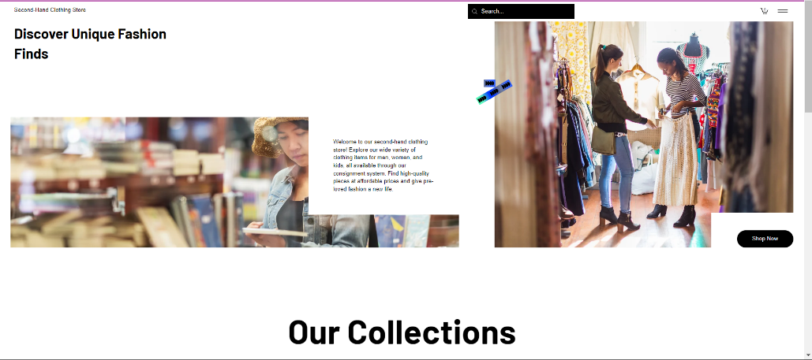

**Home Page:**

The home page is the main landing page for the second-hand clothing website. It provides users with an overview of the website and its features. The home page includes a searc bar, sticky tab menu, and a list of featured products. The home page and all other pages on the the website include a search bar which allows users to search for clothing items based on a variety of criteria, such as clothing name, brand name, and keywords.

**Search Page**

The search page includes a number of filters that allows users to narrow down their search results. For example, users can filter their resluts based on price, clothing size, and colour.

**Product Page**

The product page is the page where customers can view and purchase clothing items. The product page includes information about the item, such as the colour, quantity, size, price, and description. The product page also includes a cover image for the item. Customers can add items to their cart from the product page. Once they have added all of the items they want to purchase, they can proceed to the checkout page to complete their purchase.

**Cart Page**

The shopping cart page allows users to manage the items they wish to purchase. Users can add, remove, or adjust quantities of items in their cart. The page should automatically update the total cost and provide options to proceed to checkout or continue shopping.

**Seller Functionality Page**

This page is designed for administrators managing the selling process on behalf of users. Administrators can upload details of clothing items that users wish to sell, verify the registration of sellers, and remove sold items from the listings. It also allows administrators to manage the status of listings and update the inventory.

**Contact Page**

The contact page provides users with a way to contact the company with any questions or concerns. The page includes the company’s email address, phone number, and mailing address.

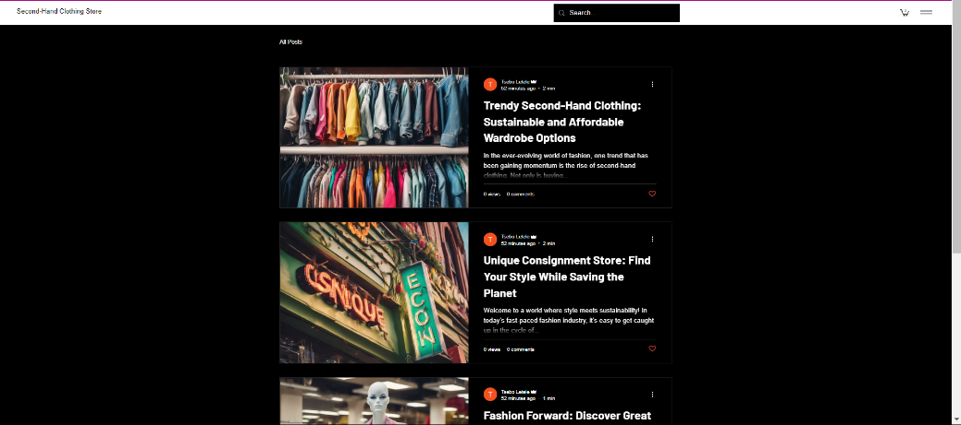

**Blog Page**

The blog page serves as a platform for sharing content related to the "Pastimes" community and the broader world of fashion, sustainability, and second-hand clothing. It could feature articles, tips, and news about trends in sustainable fashion, interviews with sellers, customer stories, and updates about the platform.

**Navigation Diagram**

**Purpose of each webpage**

* Homepage: Provides an overview of the "Pastimes" platform, emphasizing its salient characteristics and offering links to its various parts.
* Clothes Listing: Shows available used clothes products with price, brand, and category filters.
* Clothing Search: Enables users to look for certain clothing products using keywords or other search parameters.
* Clothes Purchase: Enables customers to make safe checkout transactions while buying garments.
* Shopping Cart: Organizes the products customers want to purchase, displaying the total cost and checkout choices.
* Delivery Information: During the checkout process, delivery information is gathered.
* Seller Functionality: Gives administrators the ability to update inventory, validate sellers, and control apparel listings.
* Communication: Enables administrators to have discussions about transactions with vendors and purchasers.
* About: Describes the "Pastimes" platform, the people who created it, and their goals.

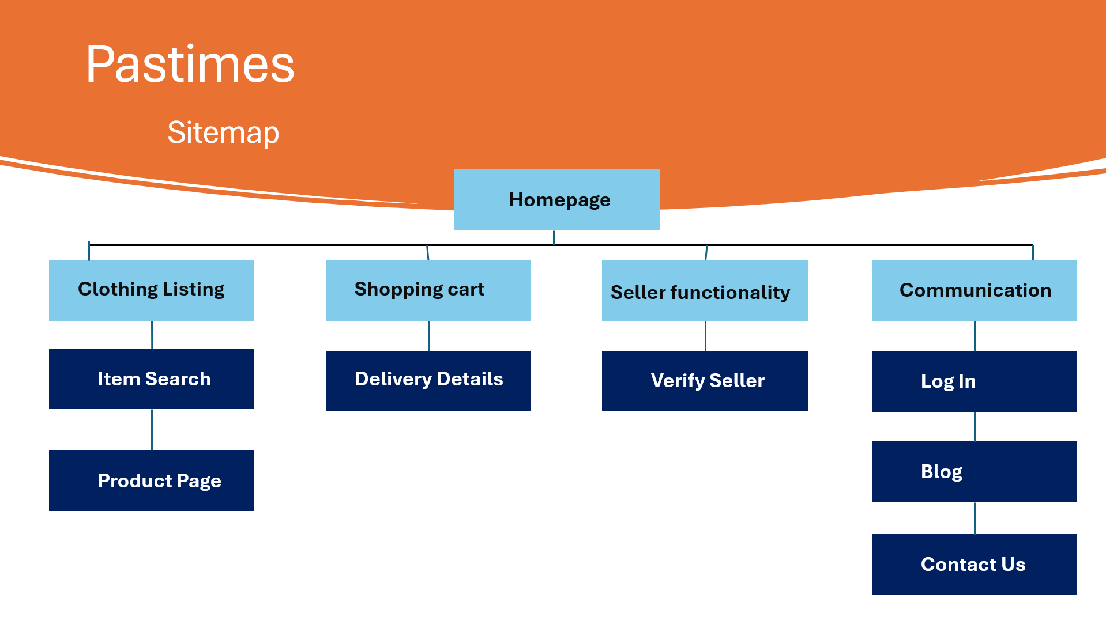

**Data needed from seller and buyer:**

Buyers:

* Profile Information: Full name, email address, and password to create an account and manage their profile.
* Contact Details: Phone number and preferred shipping address for order delivery.
* Payment Information: Credit card details or preferred payment method for processing transactions securely.
* Order History and Preferences: Cookies to track previously viewed items and search history, which will help in providing personalized recommendations.
* Wishlist: Option to save items for future purchase.
* Communication Preferences: Choices for receiving notifications and updates via email or SMS.

Sellers:

* Profile Information: Full name, email address, phone number, and password to create and manage their seller account.
* Item Details: Information about the luxury item being sold, including brand, category (e.g., clothing, footwear), detailed description, condition, and price.
* Product Images: High-quality photos of the item to attract potential buyers.
* Item Specifications: Size, measurements, and any available authenticity certificates.
* Shipping Preferences: Options for shipping methods and details on item location for accurate delivery calculations.
* Payment Details: Banking information for receiving payments once the item is sold.
* Return Policy: If applicable, details about the return policy they offer to buyers.

**Use-case Diagram**

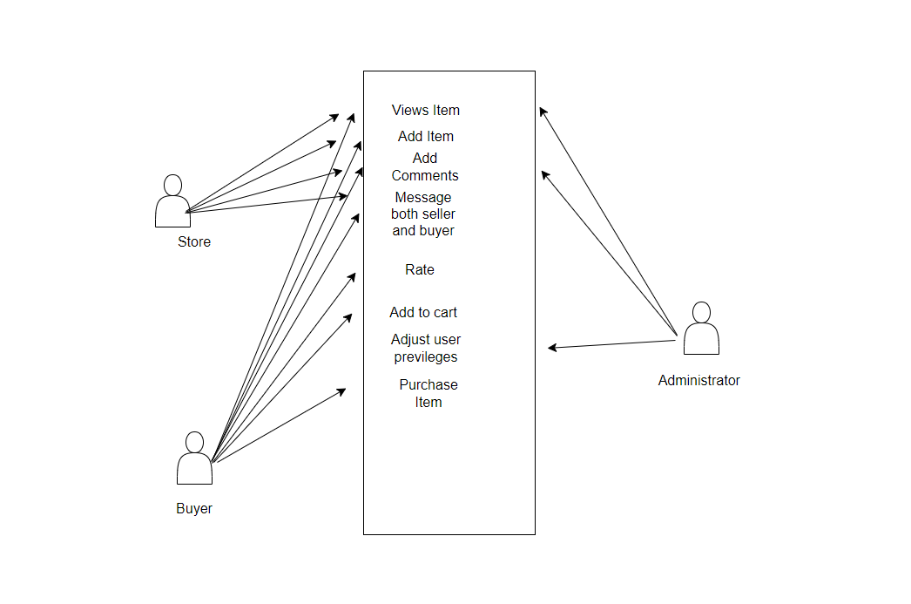

**ERD Diagram**

**Project Plan**

Project details:

Project name: Web application

Project due date: 11 November 2024

Start date: 12 August 2024

Part 1 due date: 2 September 2024

Part 2 due date: 10 October 2024

Part 3 due date: 11 November 2024

Status: In progress

Objective:

The objective of the project is to develop "Pastimes," an easy-to-use online platform that makes it easier to purchase and sell branded, gently worn clothing in excellent shape. Users should find it simple to sign up, log in, and conduct transactions—like browsing, purchasing, and selling apparel items—through the program. In order to provide a seamless and secure trading experience for both buyers and sellers, the system must guarantee that user data is safely saved and retrieved from a MySQL database. Additionally, administrators should be able to control the clothes listings and transactions.

Stakeholders:

Customers: User/ sellers/ buyers

Pasttimes administrator

Lecturer: advisor

Business Owner/s

Requirements:

1. Having each part done by the due dates

2. The program that must be used for the database is PHP and MySQL

3. HTML, CSS, and JavaScript must be used to create the web application.

4. Feedback from lecturer must be applied to the application.

**CONCLUSION**

The "Pastimes" web application provides a convenient and secure platform for users to buy and sell branded used clothing. With its user-friendly design, innovative features, and a focus on both functional and non-functional requirements, the application is built to promote seamless interaction, safety, and efficiency for all users. The comprehensive project plan ensures that the platform meets the needs of its community while maintaining high standards of quality and usability.

# References

AppsRhino. (2024, May 20). *Top 8 Must-Have Features of a Clothing Store App*. Retrieved from appsrhino: https://www.appsrhino.com/blogs/top-8-must-have-features-of-a-clothing-store-app

Matuszewska, K. (2022, November 15). *Top 4 best-designed fashion websites: In-depth guide to inspire your brand*. Retrieved from centra: https://centra.com/news/best-designed-fashion-websites

Miller, E. (2017, December 8). *Innovative Design Elements That Will Improve Your Website*. Retrieved from innovationmanagement: https://innovationmanagement.se/2017/12/08/innovative-web-design-elements-that-will-improve-your-business-website/

Room, T. C. (2023). *The Changing Room Home Page*. Retrieved from thechangingroom: https://thechangingroom.co.za/

Thrifts. (2022). *Thrifts Home Page*. Retrieved from thrifts: https://www.thrifts.co.za/